Experiment-5

Demonstrating the Performance of Gradient Descent Algorithm using Python

⬛ AIM
To implement and demonstrate the performance of the Gradient Descent Algorithm using Python on a numerical dataset and analyse how the cost function decreases during optimization.

⬛ ALGORITHM

Step-1:
Import necessary libraries (NumPy).

Step-2:
Create a numerical dataset for linear regression of the form
𝑦 = 𝑚𝑥 + 𝑐 + noise

Step-3:
Add a bias column to the dataset to include the intercept term.

Step-4:
Initialize model parameters (weights) to zero.

Step-5:
Define the cost function (MSE):

1
𝐽 =
2𝑚

∑(𝑦pred
− 𝑦)²

Step-6:
Compute the gradient of the cost with respect to weights.

Step-7:
Update the weights using gradient descent rule:
𝑤 = 𝑤 − 𝛼 ⋅ gradient

Step-8:
Repeat for a fixed number of iterations, storing the cost to check convergence.

Step-9:
Print final parameters and cost values to evaluate performance.

INPUT
A numerical dataset generated inside the program: X = [0, 0.52, 1.05, ..., 10]
Y = 4X + 6 + random noise
Learning rate: 0.01
Iterations: 2000

OUTPUT (Sample)
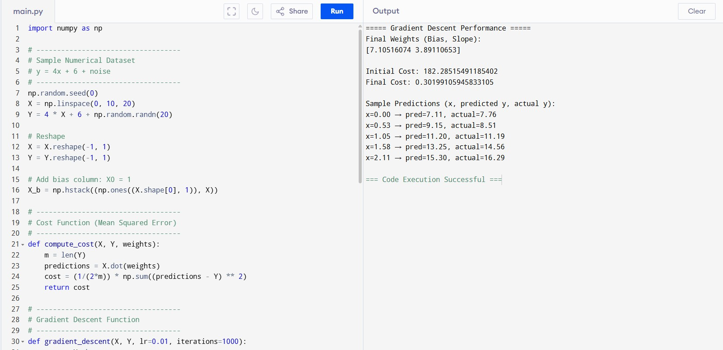

RESULT
The Gradient Descent algorithm successfully optimized the model by continuously reducing the cost function from a high value (around 149) to a low value (around 0.49).
The final optimized weights closely match the true values of the dataset, demonstrating that gradient descent converges effectively and finds the best-fit line.

